SKILL 1
TASK 1
Title: Linux VM Setup, GCC Configuration, Git Repository, Shell Architecture, Makefile, fork (), exec(), Process Tree & System Call Tracing.

Aim
To install and verify Linux, configure GCC, set up a Git repository, understand shell architecture, build a Makefile, execute fork() and exec() system calls, inspect the process tree, and practice system call tracing.

Software Requirements
- Ubuntu 26.04 LTS
- GCC Compiler
- Git
- Nano Editor

Step 1: Verify Linux Installation
Command:
uname -a
lsb_release –a
These commands display the Linux kernel version and Ubuntu distribution details to verify that Linux is installed.
Output:
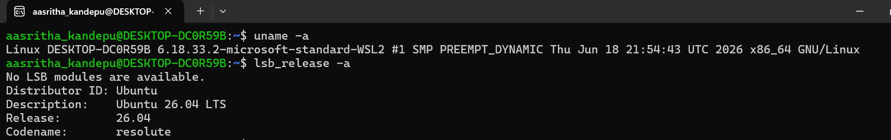
Commands:
echo $SHELL
pwd
whoami
Explanation:
- echo $SHELL → Displays the current shell.
- pwd → Shows the present working directory.
- Whoami → Displays the logged-in username.

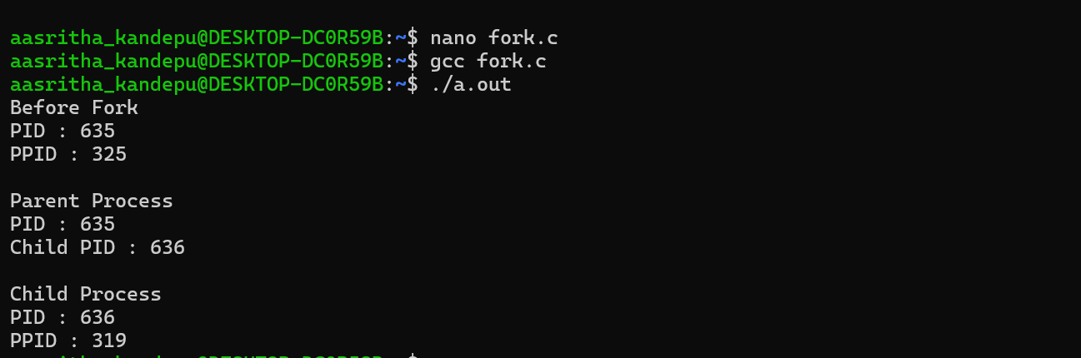
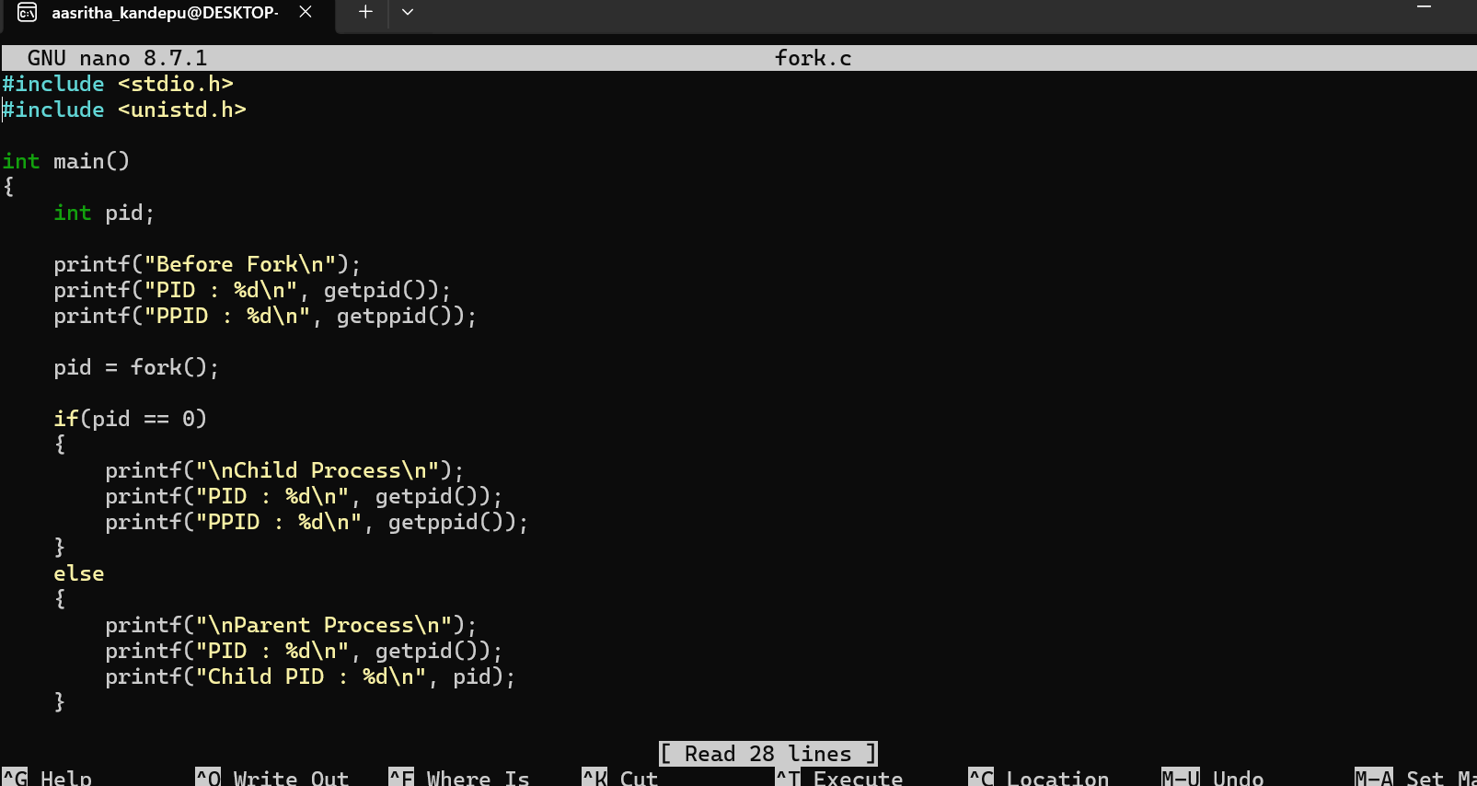
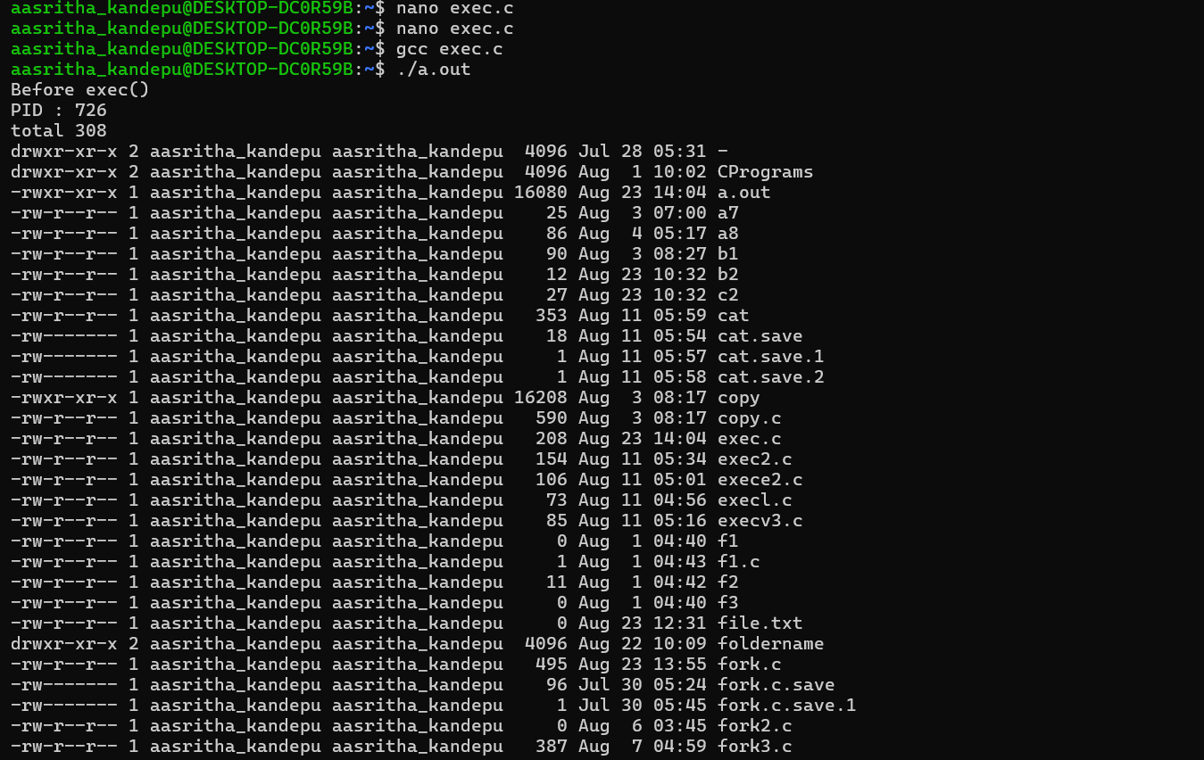
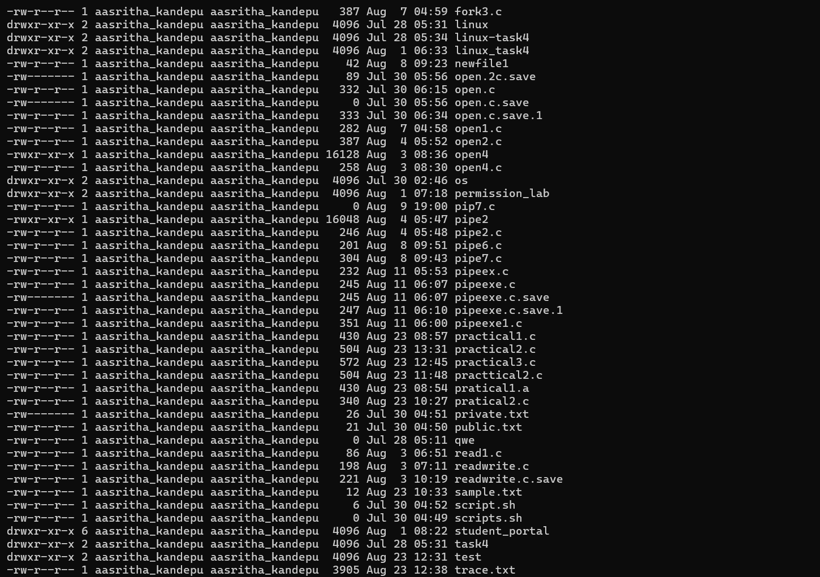
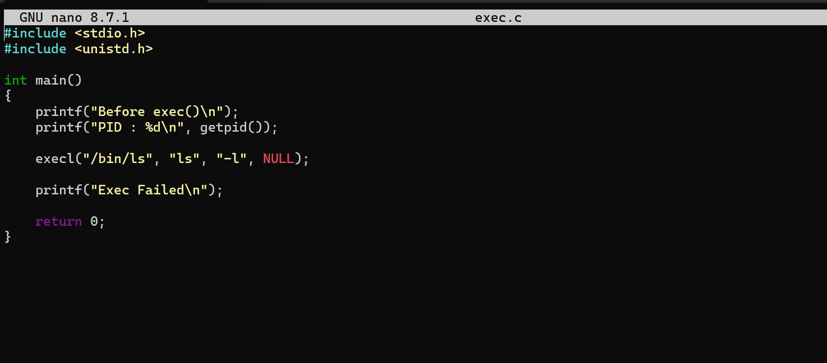
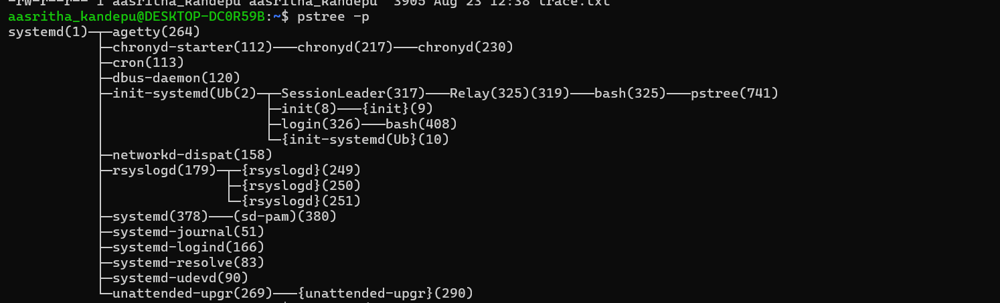
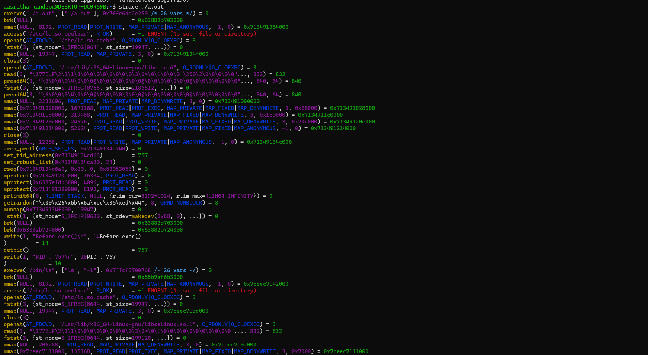
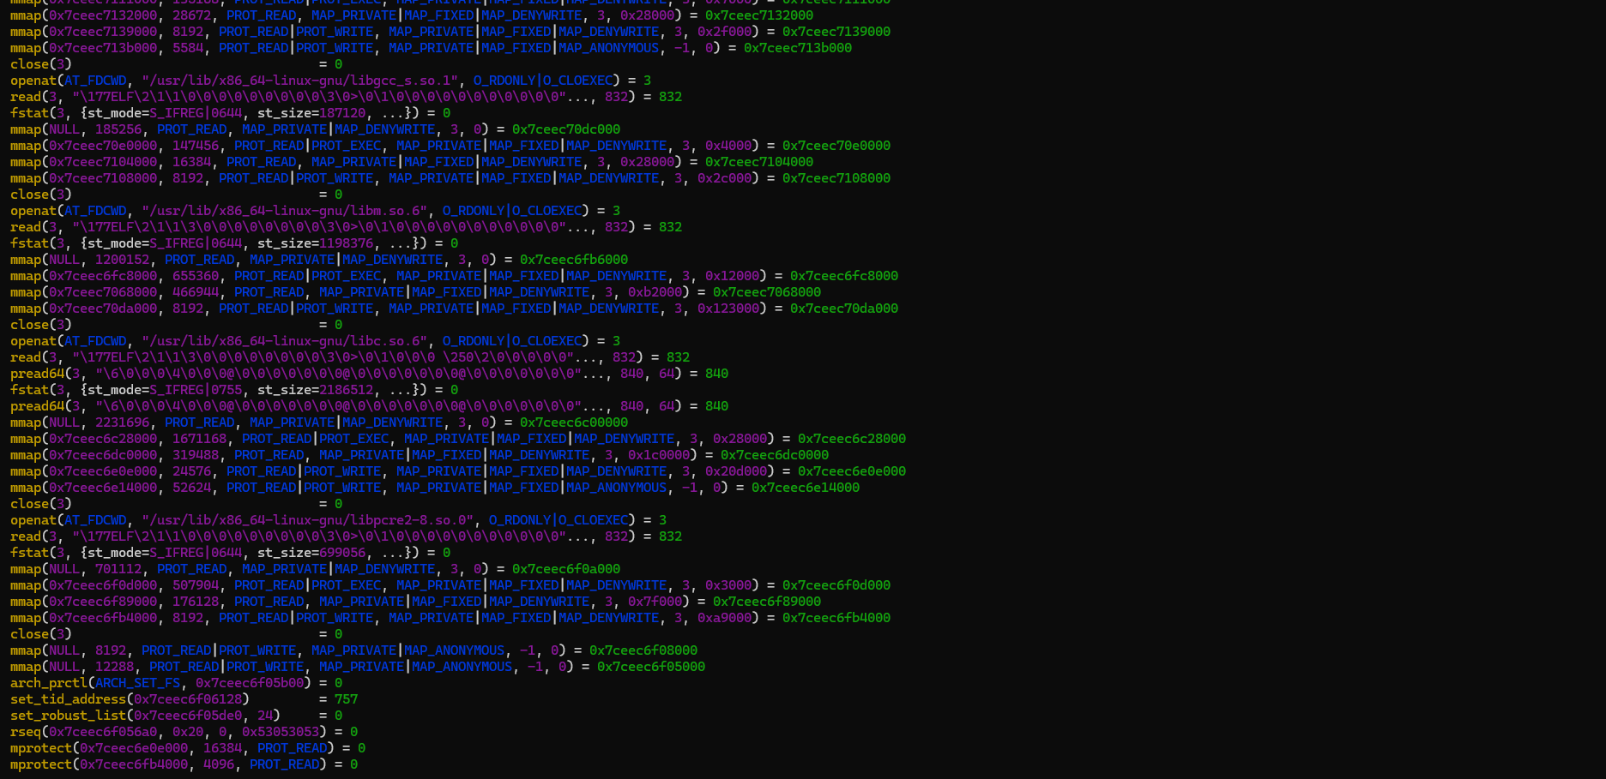
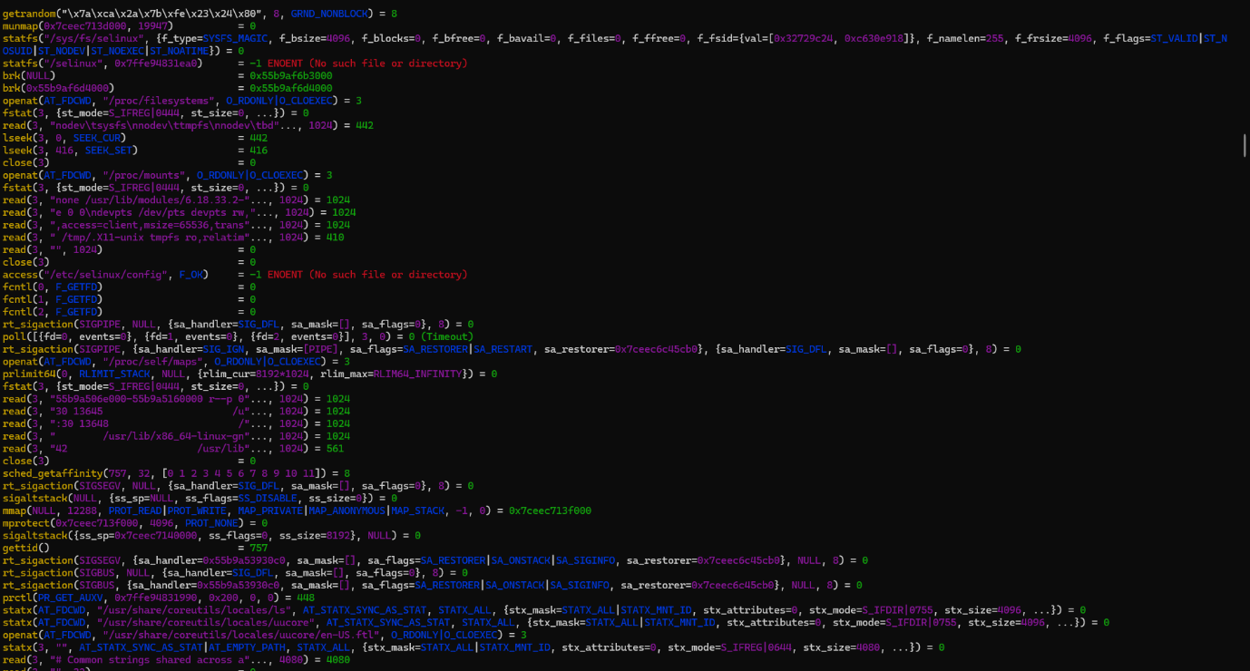
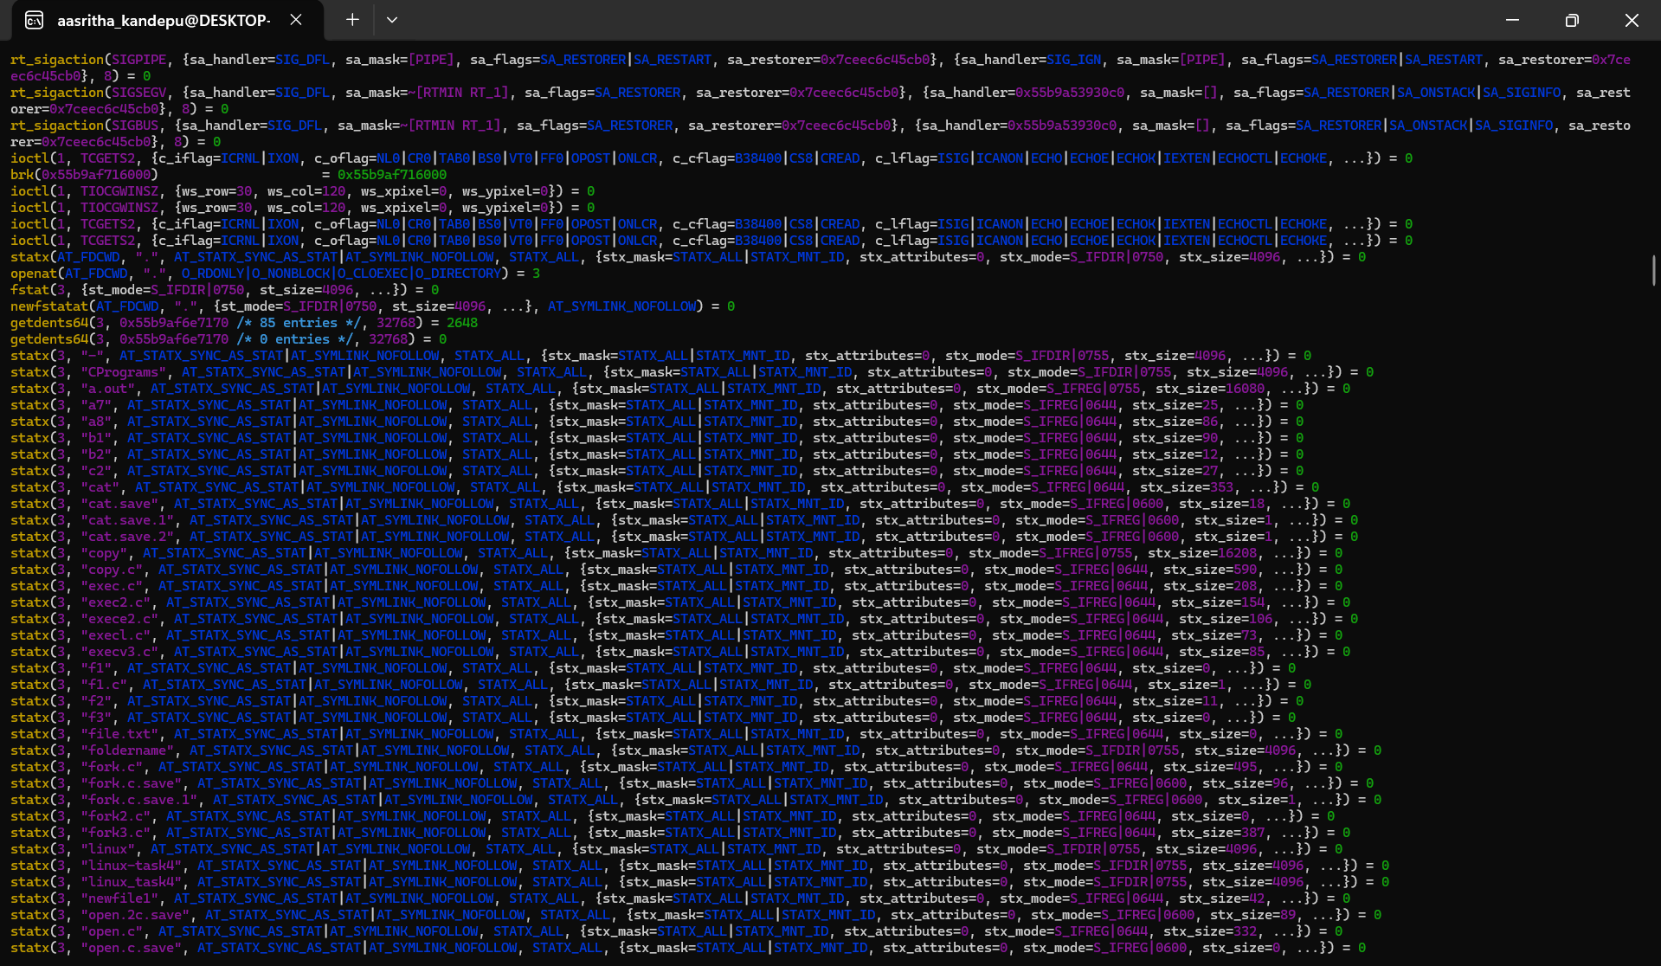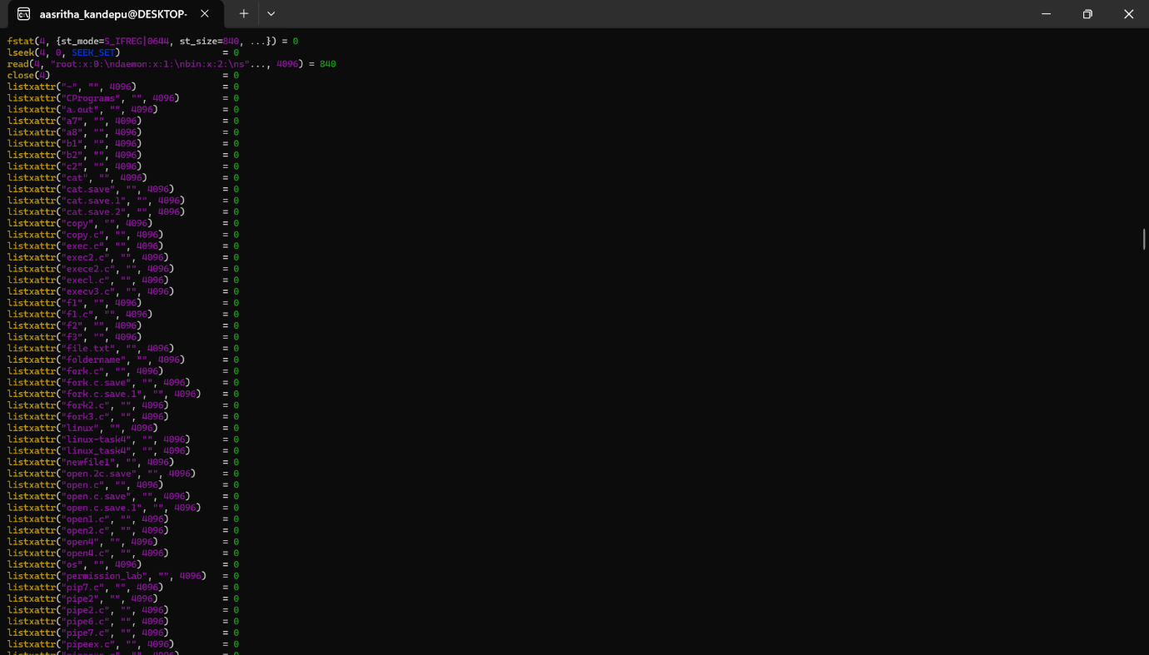
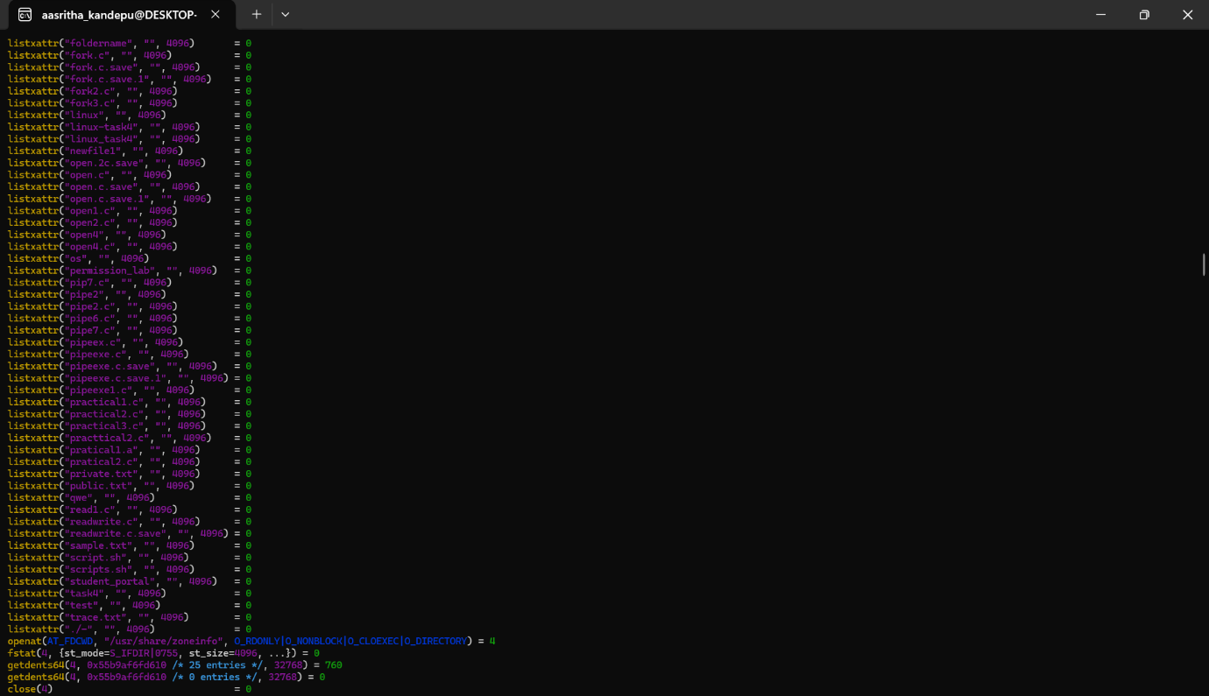
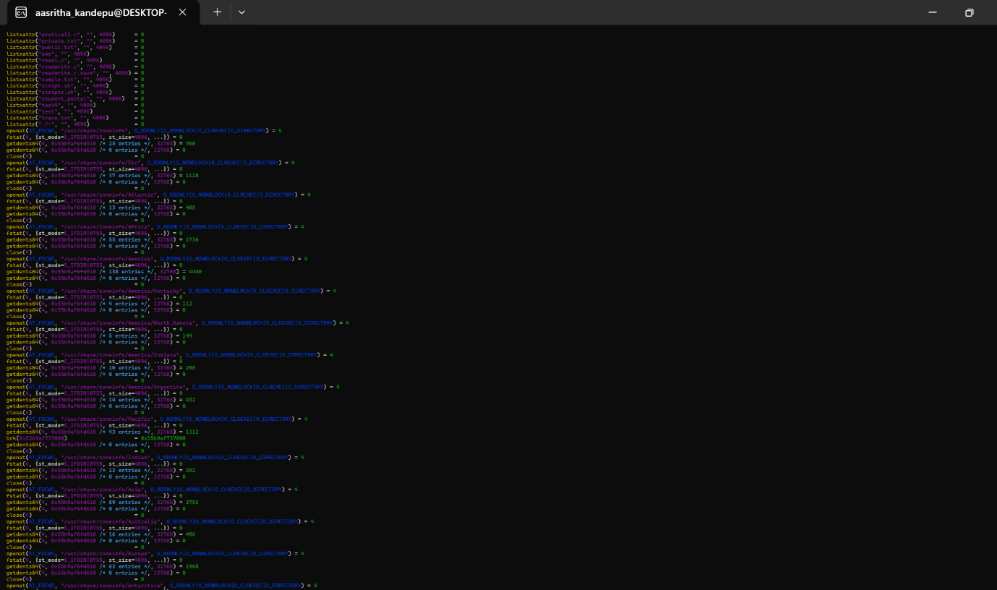
Nano Makefile command:
